MARKER’S REPORT

Name of Marker : Munish Kumar

Course Code/Title : ANL252

Semester : Jul 2022

PART I

Overall Performance of Students in the Examination:

Briefly Describe:

Majority of students passed. I am quite heartened by their performance. Excluding the no shows, the passing rate was >90%. Of 33 students graded, the only failure was due to an incomplete paper. Shown below is the Mean grade of 67.09%.

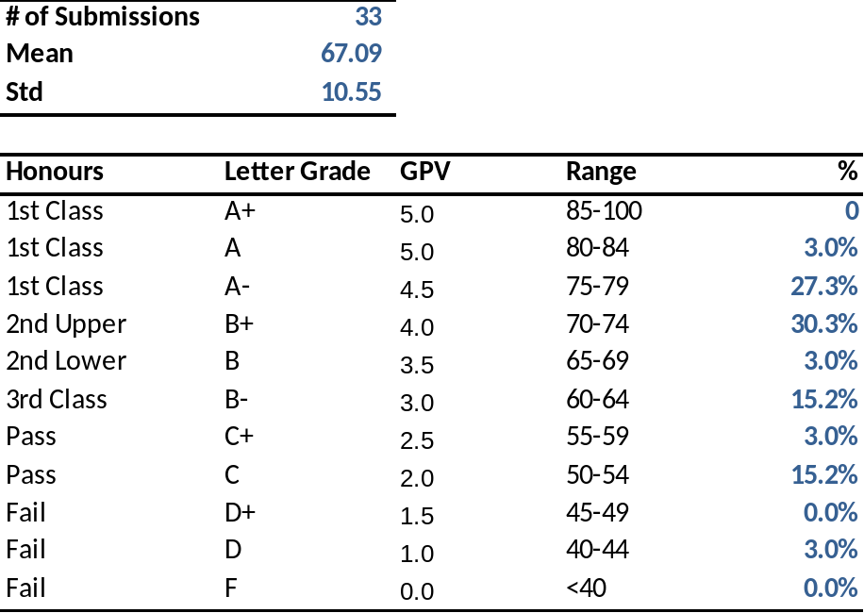

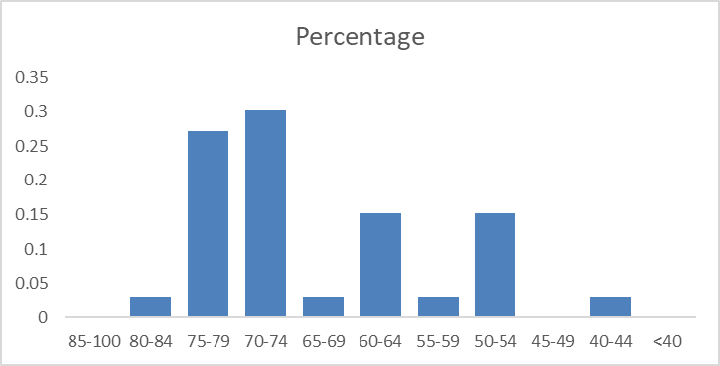

Strengths and Weaknesses of Students in Examination:

Students can be broadly categorized into 2 groups. For students that generally understood the programming goals and methods, their shortcoming was actually poor analytics. For students who had a strong grasp of the theory, they were creative in the programming choices and wrote very elegant, efficient codes. In fact, one of the things that I am most pleased by is that things that were taught in class were applied and demonstrated for example importance of normalization, or things related to documenting the code. The jupyter notebooks for those students that did well were also very neat and elegant

Poorer students struggled with conceptual basics. I think it would help if future modules incorporated some element of programming design, “pseudo code” writing, or analysis of logic.

PART II

Overall performance of Question 1 to 6.

Please see the Bloom Learning outcomes score below
S/N | Learning Outcomes | Bloom’s Level | Mean Score | Pass Rate
1 | Differentiate the various aspects of Python programming. | 1 | 3.65 | 72.94
2 | Prepare data for analysis using Python programming. | 2 | 14.12 | 70.59
3 | Analyse data using appropriate tools and techniques with Python programming. | 3,4 | 17.49 | 69.94
4 | Employ logic control flows in Python programmes. | 5 | 8.38 | 55.88
5 | Design Python programmes for performing data analytics. | 6 | 6.94 | 69.41

Strengths and weaknesses of students with regard to Question
1 to 6

Most students did reasonably well when it came to showing their skills with python, refer to statistics below

Question | 1 | 2 | 3 | 4 | 5 | 6
Mean | 3.65 | 14.12 | 17.50 | 17.47 | 8.38 | 6.94
Standard Error | 0.19 | 0.54 | 0.52 | 0.68 | 0.58 | 0.26
Median | 4.00 | 15.00 | 18.00 | 18.00 | 10.00 | 7.00
Mode | 5.00 | 15.00 | 20.00 | 18.00 | 10.00 | 8.00
Standard Deviation | 1.12 | 3.12 | 3.05 | 3.96 | 3.40 | 1.50
Sample Variance | 1.27 | 9.74 | 9.29 | 15.71 | 11.58 | 2.24
Kurtosis | -1.33 | 0.82 | 0.42 | 6.55 | 1.52 | 2.60
Skewness | -0.19 | -0.45 | -0.31 | -2.06 | -1.17 | -1.16
Range | 3.00 | 15.00 | 15.00 | 23.00 | 15.00 | 8.00
Minimum | 2.00 | 5.00 | 10.00 | 2.00 | 0.00 | 2.00
Maximum | 5.00 | 20.00 | 25.00 | 25.00 | 15.00 | 10.00
Sum | 124.00 | 480.00 | 595.00 | 594.00 | 285.00 | 236.00
Count | 34.00 | 34.00 | 34.00 | 34.00 | 34.00 | 34.00
Confidence Level(95.0%) | 0.39 | 1.09 | 1.06 | 1.38 | 1.19 | 0.52

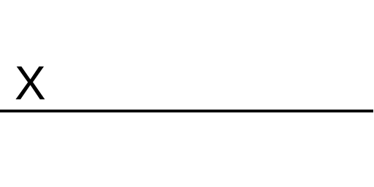 |  | Sept 2022
Marker’s Signature |  | Date

